Midterm (CSCI 4310/6323,Spring 2021)

Instructor: Dr. Bin Fu

92/100

P1: 20/20
P2: 20/20
P3: 20/20
P4: 20/20
P5: 12/20

Due 10:30pm March 26, 2021 (Friday). Download the word file and type your solution under each problem at the same file. Your submission need to be at word file instead of PDF so that it is easy to grade. Submit your word file to blackboard. If there is any problem to upload to blackboard, send your midterm to bin.fu@utrgv.edu with Subject: Algorithm Midterm--First Name Last Name.

Name: Ulvi Bajarani ID: 20539914
- Solve the recursive equations with big-O notation.
- 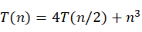 with T(1)=1.
- How many lines, as a function of n, does the following program print? Write a recurrence and solve it. You many assume n is a power of 2.
function f(n)
If (n>1)
{ Print.line(“still going”);
f(n/2); f(n/2); f(n/2);
}

Answer 1:

a) If we write the formula as T(n) = aT(n/b)+cn^{r}, we can see from the question that

a=4
b=2
r=3

since log_{b}a=log₂4=2 and r>log_{b}a due to 3>2, according to the Master Theorem, we can write that T(n) = O(n^{r})=O(n³), and the main cost of the recurrence is in the top layers.

b) Each call of f(n) prints the one line [constant time] and creates three recursive calls with T(n/2), because each input is the half of the previous. So, we can write the recurrence as T(n)=3T(n/2)+1 which might be also written as T(n)=3T(n/2)+1*n⁰ . From the recurrence, a=3, b=2, r=0. Since log_{b}a=log₂3≈1.58 and r<log_{b}a due to 0<1.58, according to the Master Theorem, we can write that T(n) = O(n^{h}) = O(n^{1.58}) where h=log_{b}a. The main cost of the recurrence is in the bottom layers.
P1: 20/20

2. Generate the union for the following two bionomial heaps.

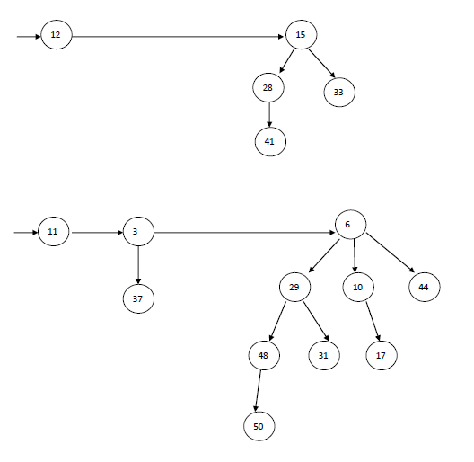

Answer 2. The images below describes step-by-step execution of union algorithm in for two provided binomial heaps. The final result is in the final step.

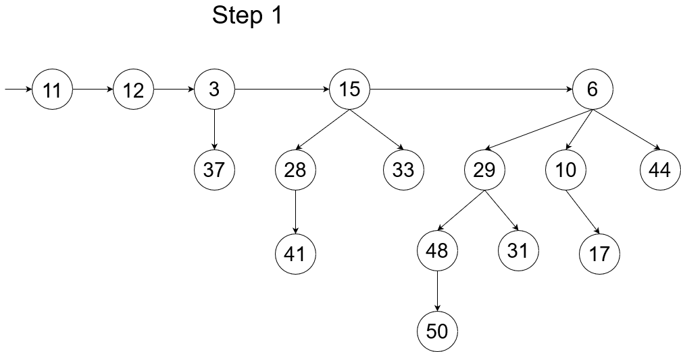

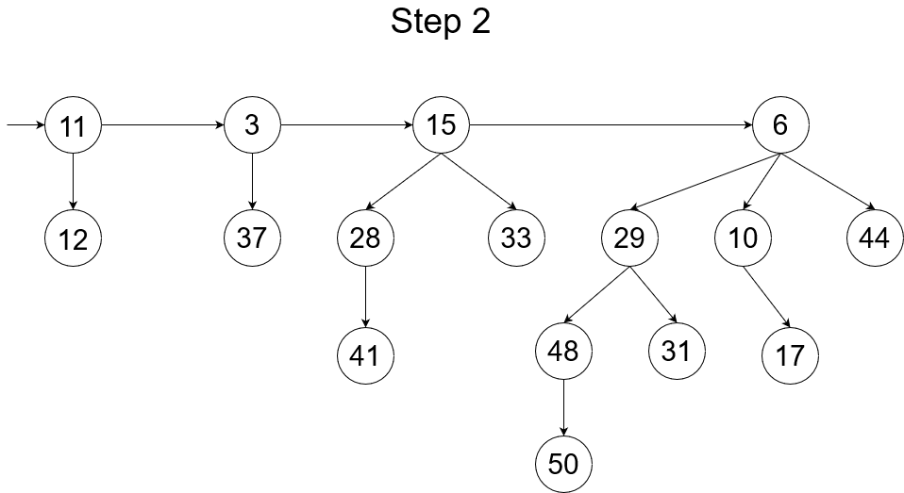

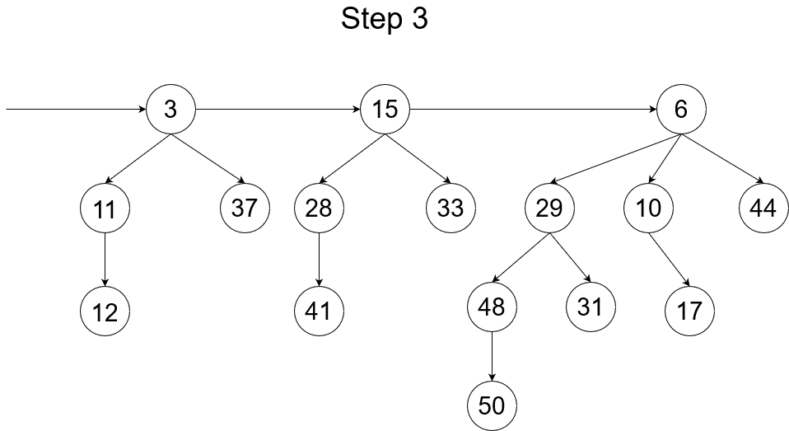

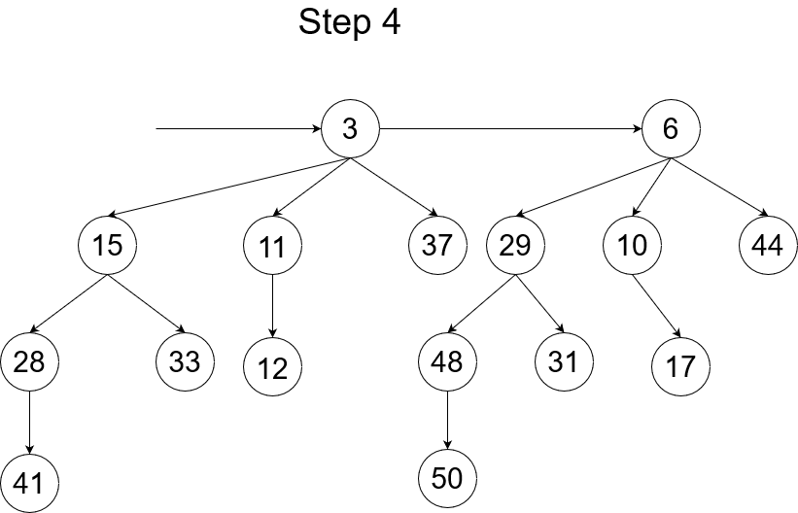

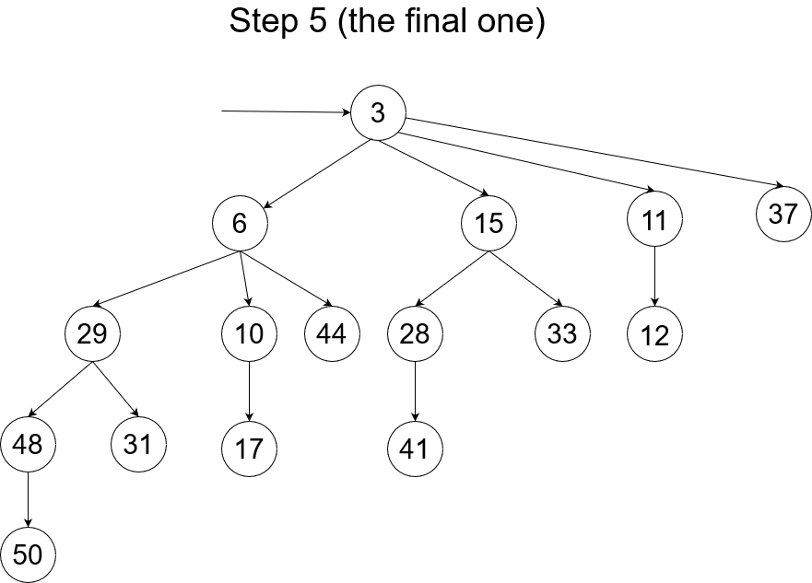

P2: 20/20
3. Delete the element 7 in a 2-3 tree, and show how the new 2-3 is formed.
5:9
3:5
7:9
1:3
4:5
6:7
8:9
1
3
4
5
6
7
8
9

Answer 3. The images below describes step-by-step execution of deletion algorithm in 2-3 trees. The final result is in the final step.

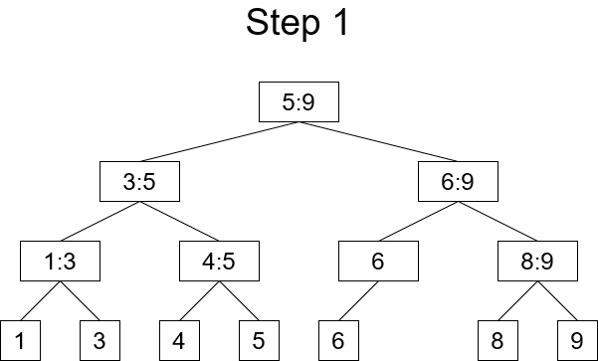
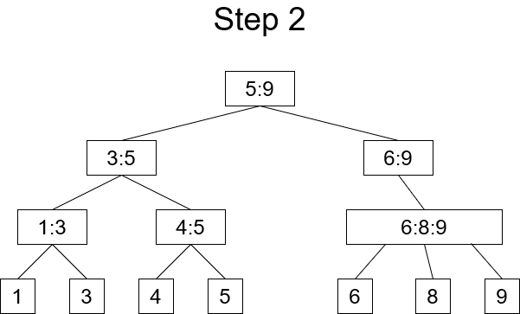

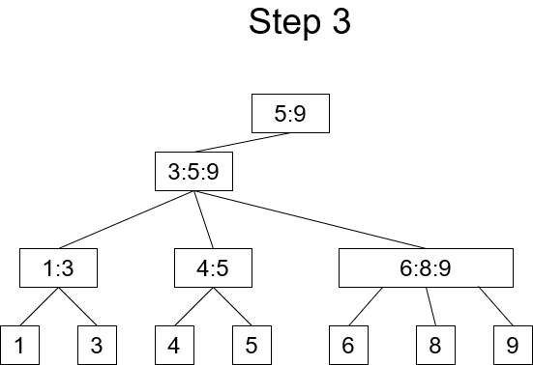

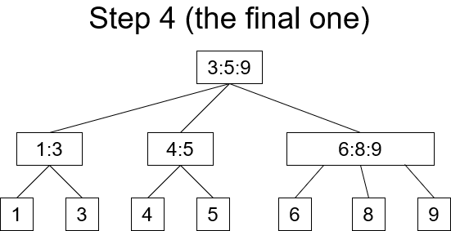
P3: 20/20

4. An array A[1…n] is said to have a majority element if more than half of its entries are the same. Given an array, the task is to design an efficient algorithm to tell whether the array has majority element, and, if so, to find that element.
- Show how to solve this problem in O(n log n) time via a divide and conquer method.
- Can you give a linear time O(n) algorithm?

Answer 4:

a) If we divide the array A with size n into two subarrays A₁ and A₂ with the size floor(n/2) each, the majority element M will remain as majority at least one of them (at most both of them). Knowing this, we can create the algorithm:

define GetMajorityElement(A[1…n]):
if n == 1:
return a[1]
set k = floor(n/2)
set majorityElementOfLeftArray = GetMajorityElement(A[1…k])
set majorityElementOfRightArray = GetMajorityElement(A[k+1…n])
if majorityElementOfLeftArray == majorityElementOfRightArray:
return majorityElementOfLeftArray
set leftArrayCounter = CountElementInArray(A[1…n], majorityElementOfLeftArray)
set rightArrayCounter = CountElementInArray(A[1…n], majorityElementOfRightArray)
if leftArrayCounter > k+1:
return majorityElementOfLeftArray
else if rightArrayCounter > k+1:
return majorityElementOfRightArray
else:
return ∅

In the each step, the algorithm creates 2 sub-arrays of size n/2, and calls counter twice. Since the counting is the linear procedure [time complexity O(n)], we can write the whole time complexity by

T(n) = 2T(n/2) + 2O(n), which is equal to O(nlogn), according to the Simplified Master Theorem [since a=2, b=2, r=1, r=log_{b}a due to 1=1, and T(n) = O(n^{r}logn)].

b) For the array A with size n, we can pair the elements to get floor(n/2) number of pairs. If the elements in the each pair are different, both elements are discarded. Else, one of them is kept. To describe if the algorithm is right, it is important to prove the lemma:

Lemma. After the algorithm, the remaining number of elements is at most floor(n/2), and if A has a majority element, the remaining elements also has the same majority element.

Proof. Let M be the majority element of array A with size n. According to the condition, M is higher than floor(n/2). Since we form sub-arrays with 2 elements [pairs], it means that at least one of them contains only M. Otherwise, M cannot be higher than floor(n/2). The maximum number of pairs after the procedure equals to floor(n/2), which is done in the case when all elements are equal to M. It means that out of floor(n/2), elements, at least one is equal to M.
We can also see what pairs are created after the procedure. For the pair (x, y), there are for possible cases:

1) x == y
2) x != y
3) (x == M) and (y != M)
4) (x != M) and (y == M)

For the first case, the majority of M is guarantied by keeping at least one x. For the cases 2-4, the majority of M is guarantied by removing another element of the pair.
The lemma holds only if there is a majority element M. To check this, we can check if the return value of CountElementInArray(A[1…n], element) is higher than floor(n/2). This is done by an additional function CheckTheMajorityElement(A[1…n]).
The final algorithm might be written as this:

define GetMajorityElementLinearly(A[1…n]):
if n == 2:
if A[1] == A[2]:
return A[1]
else:
return ∅
set k = floor(n/2)
create an empty array Temp
for i from 1 to k:
if A[2i-1] == A[2i]:
Insert A[i] into Temp.
increment i by 1
return GetMajorityElementLinearly(Temp).

Recurrence for the algorithm is equal to

T(n) = 1*T(n/2) + n.

Since a=1, b=2, r=1, log_{b}a = log₂1 = 0. Since r>log_{b}a due to 1>0, according to the Master Theorem, we can write that T(n) = O(n^{r})=O(n). The running time of CheckTheMajorityElement(A[1…n]) is also equal to O(n).

The helping procedures for algorithms above:

define CountElementInArray(A[1…n], element):
set counter = 0
for i from 1 to n:
if A[i] == element
counter += 1
increment i by 1
return counter

define CheckTheMajorityElement(A[1…n]):
set k = floor(n/2)
set MajorityElement = GetMajorityElementLinearly(A[1…n])
set counter = CountElementInArray(A[1…n], MajorityElement)
if counter > k+1:
return MajorityElement
else:
return ∅
P4: 20/20

5. An interval [a, b] covers a point c if c is in [a, b] (In other words, a≤c≤b). Develop an algorithm such that given a list of intervals, and a list of points in x-axis, it gives a least number of intervals from the given list to cover all points in the input list. For example, assume that the input list of intervals is [1,5], [2,3], and [7, 12], and the input list of points is 1,3, 4, 8, 10. The points in the input list can be covered by [1,5] and [7, 12] in the interval list of the input. Please design a dynamic programming algorithm, and give its time complexity. Clearly show your recursion.

Answer 5. If the A[1...n] is the unsorted list of elements, I is the set of intervals, to get the minimum set of intervals S, we can use the algorithm below:

define minimal-set-of-intervals(A[1...n], I):
set S = ∅
if (A[1...n] == ∅) or (I == ∅)
return S
set B = sort(A[1...n])
while B != ∅:
for each element x_{i} in B:
Merge S with first I_{i} where x_{i} ∈ I_{i}
Remove x_{i} from B where x_{i} ∈ I_{i}
return S

It might be seen that the one pass from the array is enough to create the set of intervals. Because after each execution, the set S covers the elements from x₁ to x_{i} where 1≤i≤n, so the remaining problem is the finding the solution from x_{i+1} to x_{n} . So, the time complexity of the algorithm is O(n). Since we sort the array first, we can write the time complexity as T(n) = 2T(n/2) + O(n) + O(n) = O(nlogn)+O(n) = O(nlogn)

To describe that our solution is optimal, we have to know that at least we have an interval I₁ ∈ [x₁; x₁+1]. Suppose there is another interval I₁’ ∈ [y; x₁+1] where y<x₁ . In this case, the coverage of these two intervals are equal, since there are no points laying on [y;x₁) . By this logic, if we have I₂ as the solution covering x_{i} , the set I₂’ ∈ [x_{i}; x_{i}+1] will also cover x_{i}. Consequently, I₁ ∪ I₂ will cover as the same number of elements as I₁’ ∪ I₂’

Eventually, for the remaining subproblems, the solutions set for the subproblems will not cover the elements removed before. It means that the solution set S for i sub-problems is equal to S = S₁ ∪ S₂ ∪ … ∪ S_{i}

Need a clear recursion for dynamic programming.
P5: 12/20

